Setting Up Fog

In this project, we use laptop as our FOG. This is the step to starting up the fog

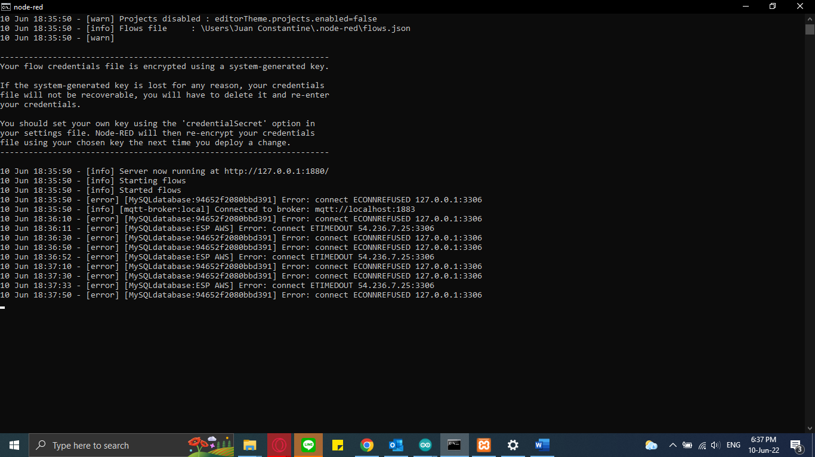

1. Turn on node red through cmd by typing :

Node-red

1. Open node red server with browser at <http://127.0.0.1:1880/>

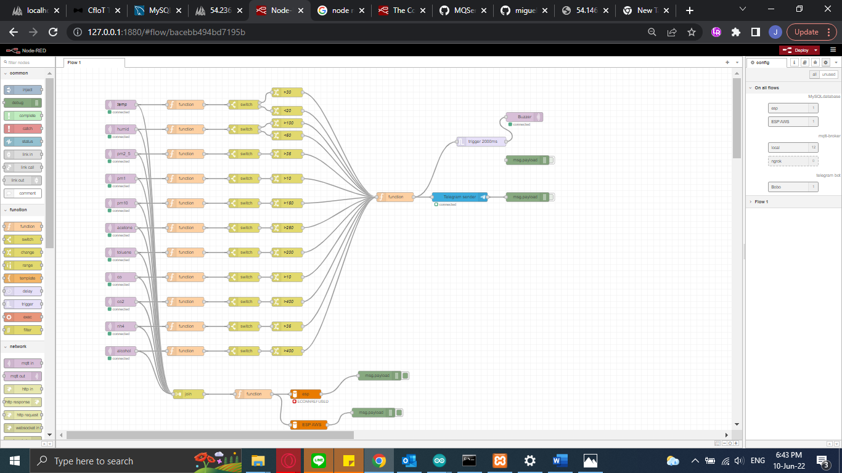

1. Open XAMMP
2. Start Apache and My SQL

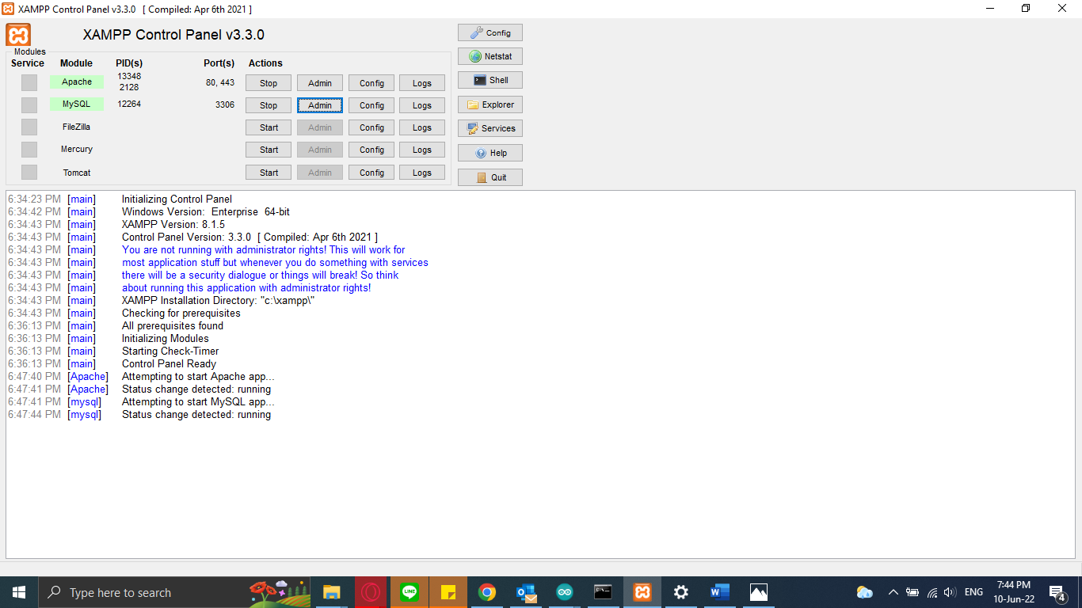

1. Click on admin button for apache module to open air quality dashboard or type localhost on the browser.

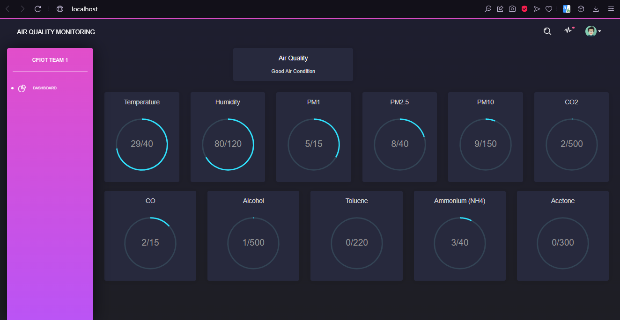

1. Also in XAMMP control panel, click on admin button for MySQL, to open database server. This database server is stored in computer

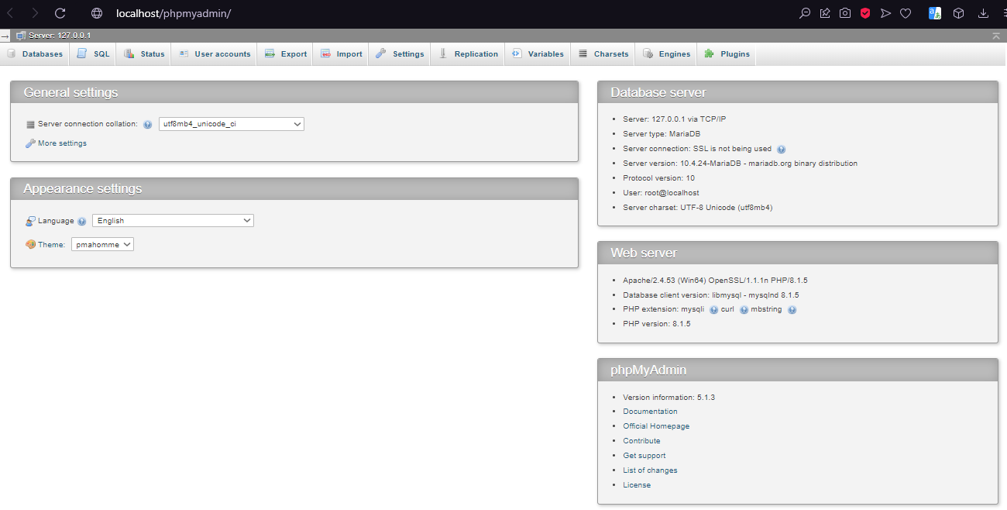

1. Turn on mobile hotspot for the ESP32 to connect. So ESP32 and the FOG are in the same network.

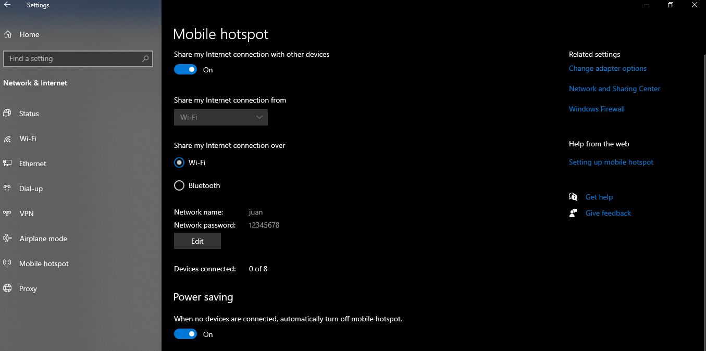

Setting Up Cloud Service

We use Amazon Web Service as our cloud. We use EC2 service.

For IoT class, we get this service for free, with 100$US limit.   
This is the step to setting up cloud service for our project:

1. Open learner lab <https://awsacademy.instructure.com/courses/13206/modules/items/1133910>

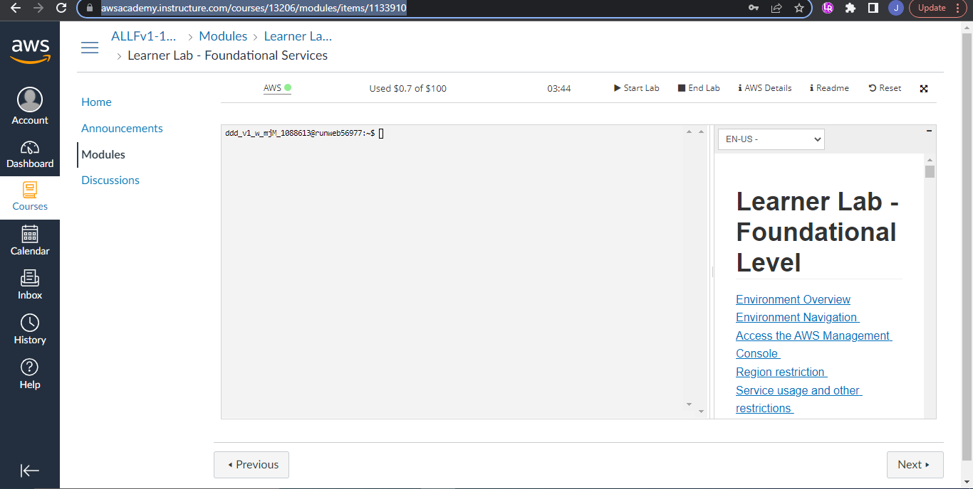

Start the lab, wait until the lamp turn green, and click it.

1. Choose EC2 Service

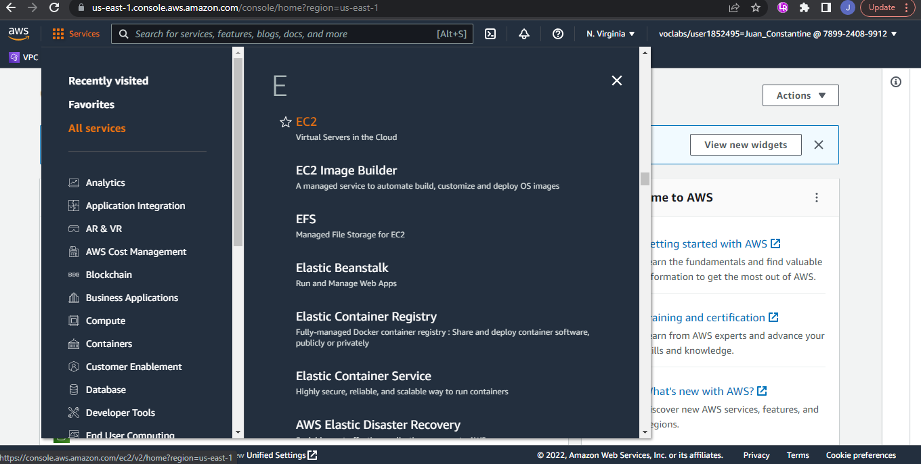

1. Click instance, click instance name, connect

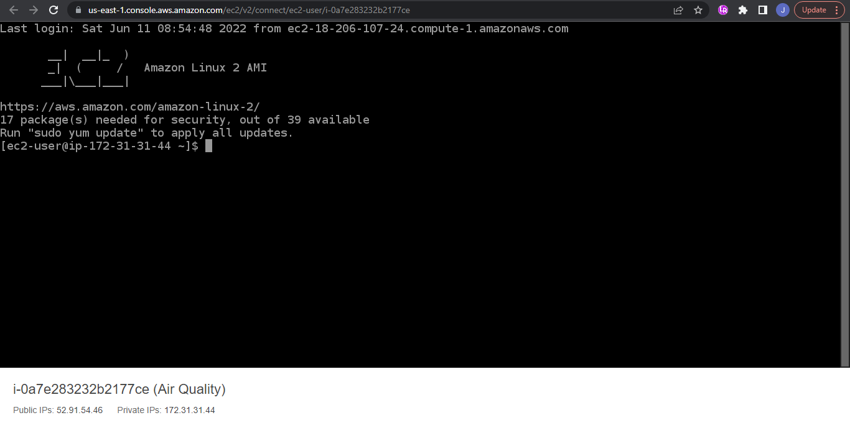

1. Open the public IPv4 address

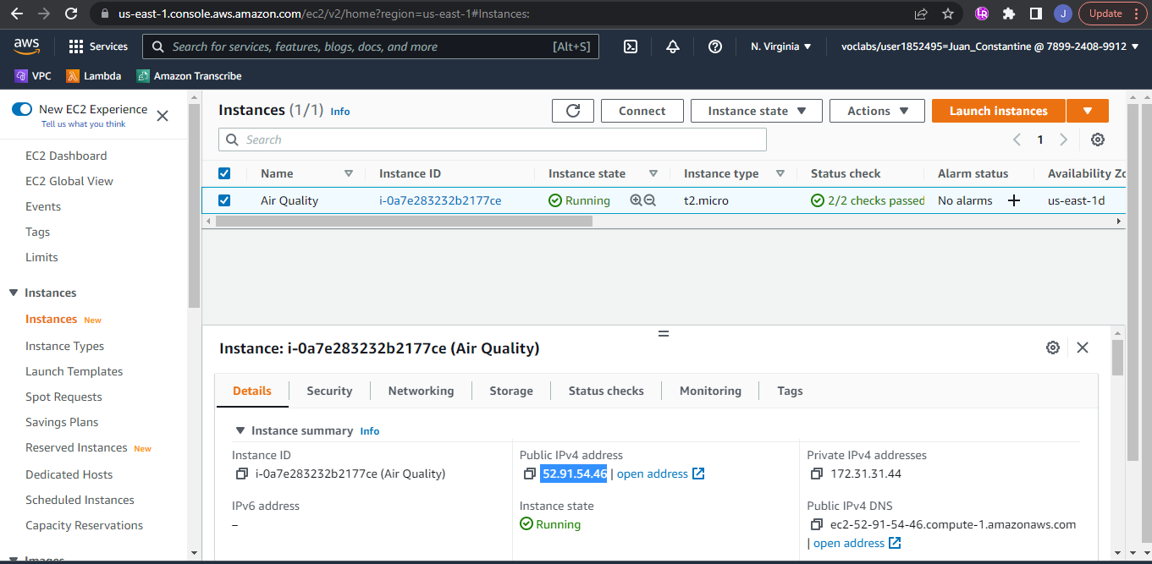

1. The Cloud dashboard is shown below. The IP address is changing every time the EC2 instance is started.

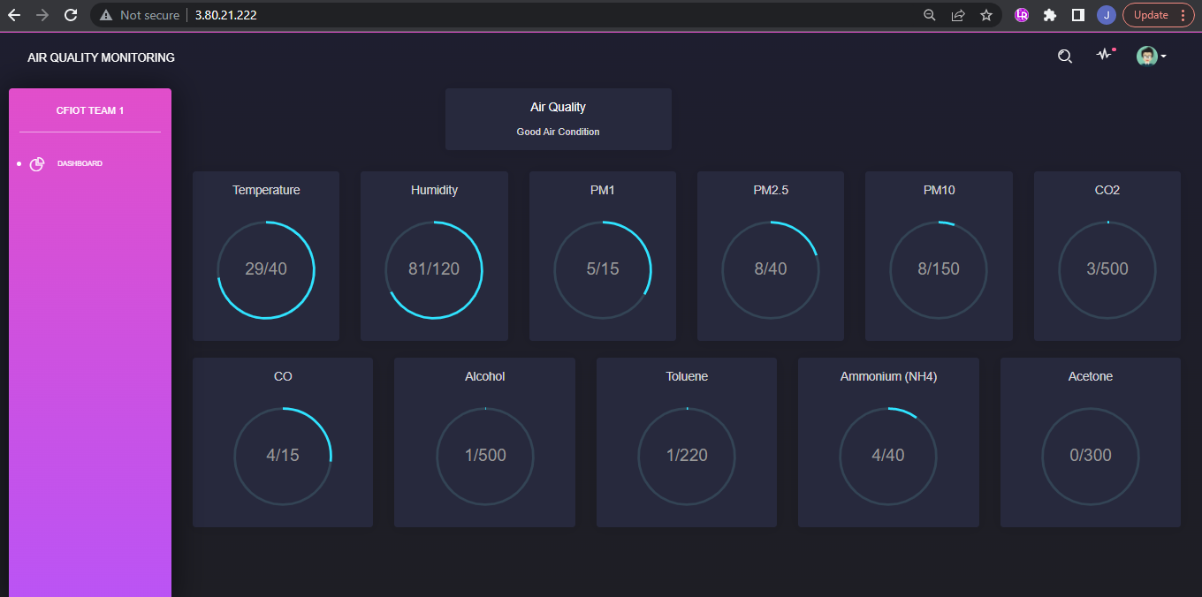

1. Then we can open the cloud database using : IPAdress/phpMyAdmin

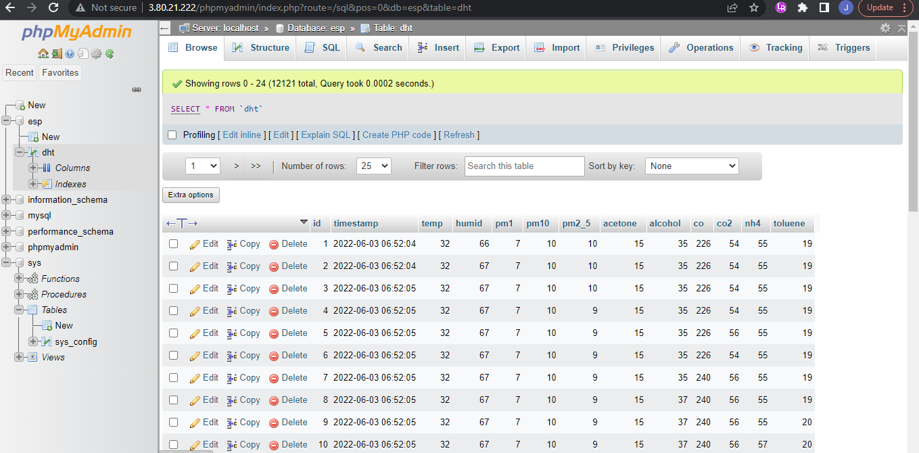

If measurement value is out of range, notification will be sent to telegram by node-red (as fog).

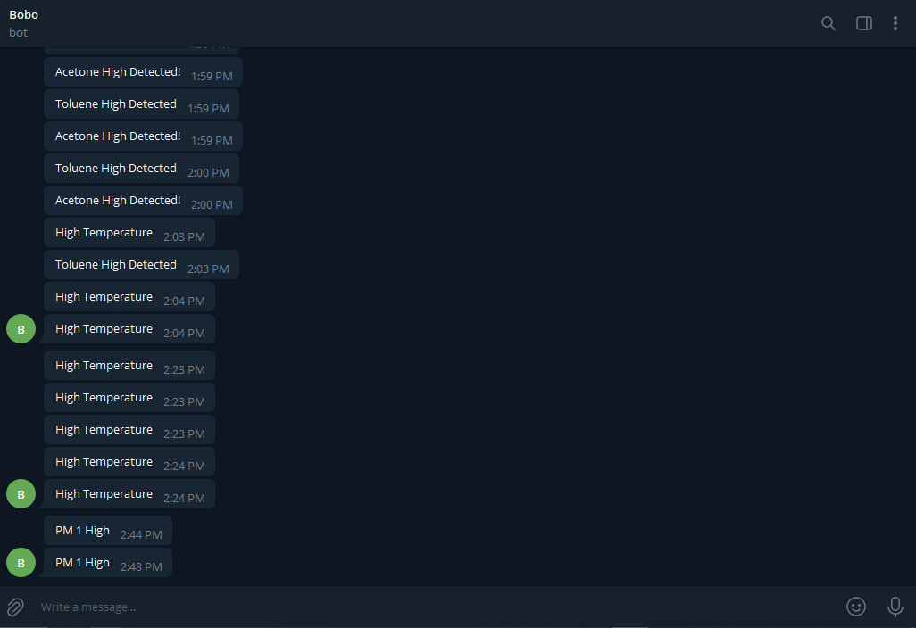

Node-red also send signal to esp32 to turn on buzzer.

